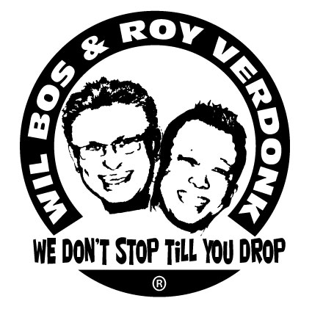
Amor Mafioso

Choreographers : Wil Bos & Roy Verdonk
Level : Intermediate
Dance : 68 counts, 2 wall
Music : Musical JM – Amor Mafioso
Intro : total 36 counts (start dance after 4 counts on the break in the intro)
Note : You dance these 68 counts for 4 walls,
Leave the last 4 counts out in the last 2 walls (The Rocking Chair)

Chasse R, Rock L Behind, Recover R, Shuffle Forward L, Step R Forward, ½ Pivot L.
1&2 Step RF to right side. Close LF beside right. Step RF to right side.
3-4 Rock back on LF, Rock forward on RF.
5&6 Step LF forward, Close RF beside RF, Step LF forward.
7-8 Step forward on RF, Pivot ½ turn left. (6.00)

Toe Strut R with a ½ turn L and snap fingers, Toe Strut L with a ½ turn L and snap fingers,
Shuffle Forward R, Step L Forward, ¼ Turn R
1-2 ½ Turn left step RF back on toes, Step down on right heel and click fingers
3-4 ½ Turn left step LF forward on toes, Step down on left heel and click fingers
5&6 Step RF forward, Close LF beside right, Step RF forward
7-8 Step left forward, ¼ turn right

Cross Shuffle L, ¼ Turn L, ¼ Turn L, Cross Shuffle R, Rock L to left side , Recover on R,
1&2 Cross LF over right, Step RF to right side, Cross LF over right
3-4 ¼ turn left step back on RF, ¼ turn left step LF to left side
5&6 Cross RF over left, Step LF to left side, Cross RF over left
7-8 Rock LF to left side, Recover on RF

Sailor Step L, Step R forward , ¼ Turn Left, Step R forward, ¼ Turn Left, Shuffle Forward R
1&2 Cross left behind right, Step right to right side, Step left to left side
3-4 Step RF forward, ¼ turn left
5-6 Step RF forward, ¼ turn left
7&8 Step RF forward, Close LV beside right, Step RF forward.

Step Forward L, ½ Turn R with Hook R, Shuffle Forward R,

Step Forward L, ½ Turn R with Hook R, Shuffle Forward R
1-2 Step Forward on LV, Make a ½ turn right and hook RF in front of left shin
3&4 Step RF forward, Close LV beside right, Step RF forward.
5-6 Step Forward on LF, Make a ½ turn right and hook RF in front of left shin
7&8 Step RF forward, Close LV beside right, Step RF forward.

Step Forward L, ¼ Turn to left, Step R Right, Sailor Step L, Cross R, Side L, Coaster Step R
1-2 Step LF forward, Make ¼ turn left and step RF to the right side
3&4 Cross left behind right, Step right to right side, Step left to left side
5-6 Cross RF over LF, Step LF to left side
7&8 Step back on RF, Close LF next to right, Step RF forward

Rock L Forward, Recover R, Touch L Back, ½ Turn L, Rock R Forward, Recover L, Touch R Back, ½ Turn R
1-2 Rock LF forward, Recover on RF
3-4 Touch toes LF back, ½ turn left step down on left heel (take weight on LF)
5-6 Rock RF forward, Recover on LF
7-8 Touch toes RF back, ½ Turn right step down on right heel ( take weight on RF)

Shuffle ½ Turn R, Rock Back R, Recover on L, Full Turn L (R-L), Step R Forward, Pivot ½ Left
1&2 ¼ turn right step LF to left side, Close RF next to LF, ¼ turn right step back on LF
3-4 Rock RF back , Recover on LF
5-6 Make ½ turn left and step back on RF, Make ½ turn left step LF forward. ( option walk RF walk LF forward)
7-8 Step right forward, Pivot ½ turn left.

Rocking Chair R
1-2 Rock forward on RF, Recover on LF
3-4 Rock back on RF, Recover on LF

You dance these 68 counts for 4 walls, Leave the last 4 counts away in the last 2 walls (The Rocking Chair)

Start again smile and have fun

